

|  |  |  |  |
| --- | --- | --- | --- |
|  |  |  |  |
|  |  |  | 2023-24 |
|  |  | | |



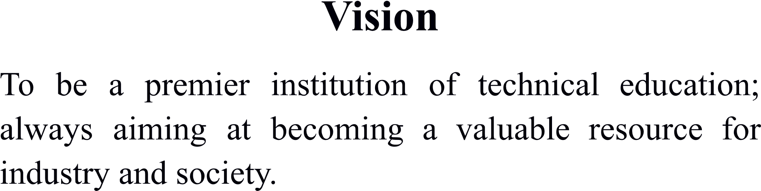







|  |  |
| --- | --- |
|  |  |
|  |  |
|  |  |
|  |  |
|  |  |
|  |  |

|  |  |  |  |
| --- | --- | --- | --- |
|  | |  |  |
|  |  |  |  |
|  |  |  |  |
|  |  |  |  |
|  |  |  |  |
|  |  |  |  |
|  |  |  |  |

|  |  |  |
| --- | --- | --- |
|  |  |  |
|  |  |  |
|  |  |  |
|  |  |  |
|  |  |  |
|  |  |  |
|  |  |  |
|  |  |  |
|  |  |  |
|  |  |  |
|  |  |  |

|  |  |  |  |  |  |  |
| --- | --- | --- | --- | --- | --- | --- |
|  |  | | | | | |
|  |  |  |  |  |  |
|  |  |  |  |  |  |  |
|  |  |  |  |  |  |  |
|  |  |  |  |  |  |  |
|  |  |  |  |  |  |  |
|  |  |  |  |  |  |  |
|  |  |  |  |  |  |  |

|  |  |  |  |  |  |  |
| --- | --- | --- | --- | --- | --- | --- |
|  |  |  |  |  |  |  |
|  |  |  |  |  |  |  |
|  |  |  |  |  |  |  |
|  |  |  |  |  |  |  |

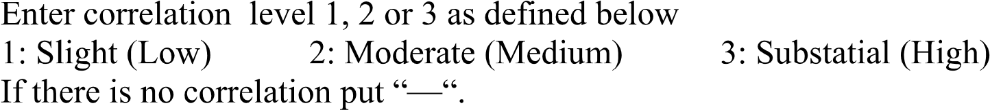

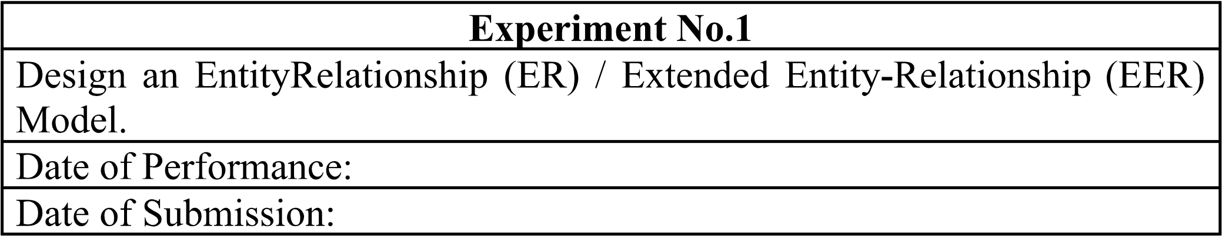

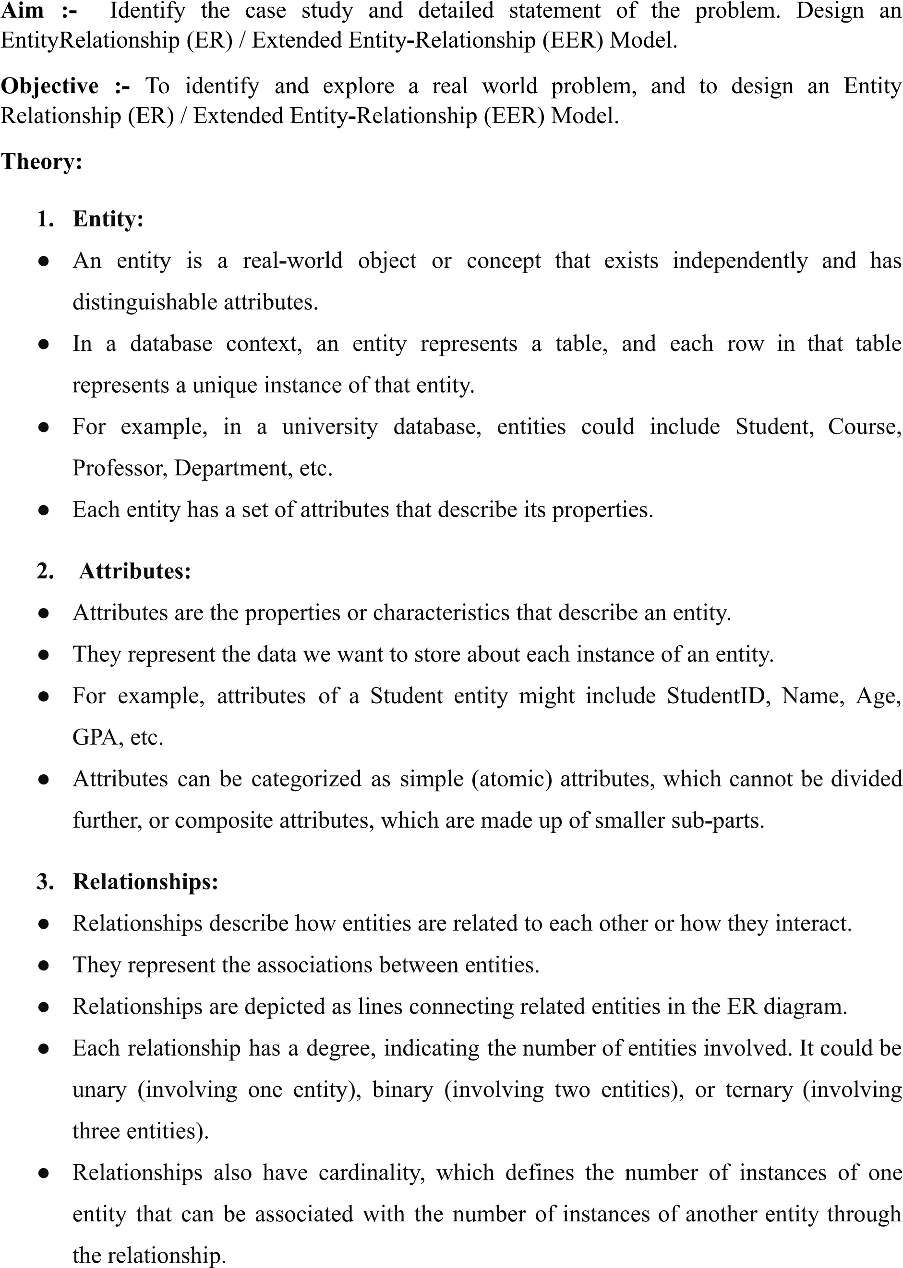

4. Cardinality:

* Cardinality specifies the number of instances of one entity that are related to the number of instances of another entity through a relationship.
* It defines the maximum and minimum number of occurrences of one entity that can be associated with the occurrences of another entity.
* Common cardinality constraints include:
  1. One-to-One (1:1): Each instance of one entity is associated with exactly one instance of another entity, and vice versa.
  2. One-to-Many (1:N): Each instance of one entity is associated with zero or more instances of another entity, but each instance of the second entity is associated with exactly one instance of the first entity.
  3. Many-to-One (N:1): The reverse of One-to-Many; many instances of one entity are associated with one instance of another entity.
  4. Many-to-Many (N:N): Many instances of one entity can be associated with many instances of another entity.

Implementation:

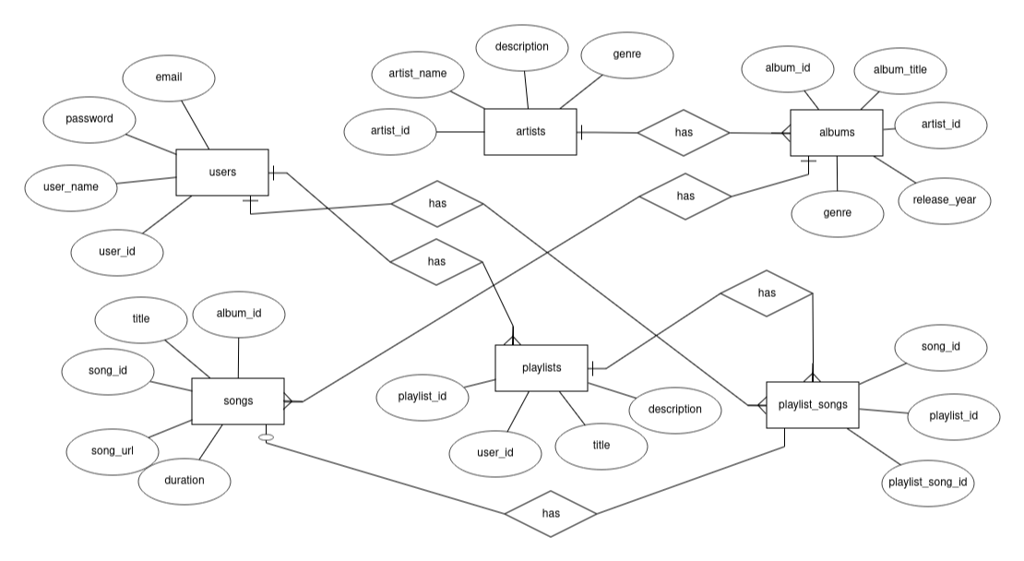



Conclusion:

* 1. Define Entity, Attributes (also types) and Relationship between entities

Entity: Represents a real-world object or concept in a database.

Attributes: Characteristics of entities with defined data types.

Relationships: Connections between entities, defining how they interact or associate with each other.

* 1. Write ER/EER diagram notations

Entities: Rectangles or ovals.

Attributes: Ellipses connected to entities by lines.

Primary Key Attribute: Underlined attribute.

Composite Attribute: Attributes nested within ellipses.

Multivalued Attribute: Double oval.

Derived Attribute: Dashed ellipse.

Relationships: Diamonds or lines connecting entities. Cardinality: Indicates the minimum and maximum number of instances in a relationship using crow's foot notation. Participation Constraint: Total participation denoted by a double line.

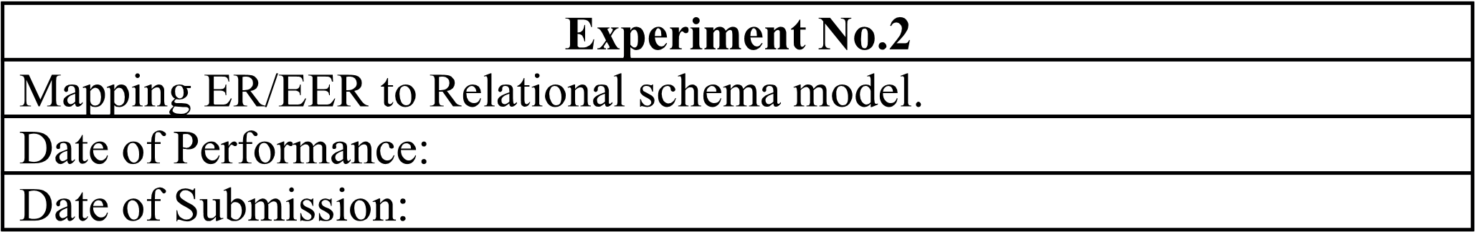

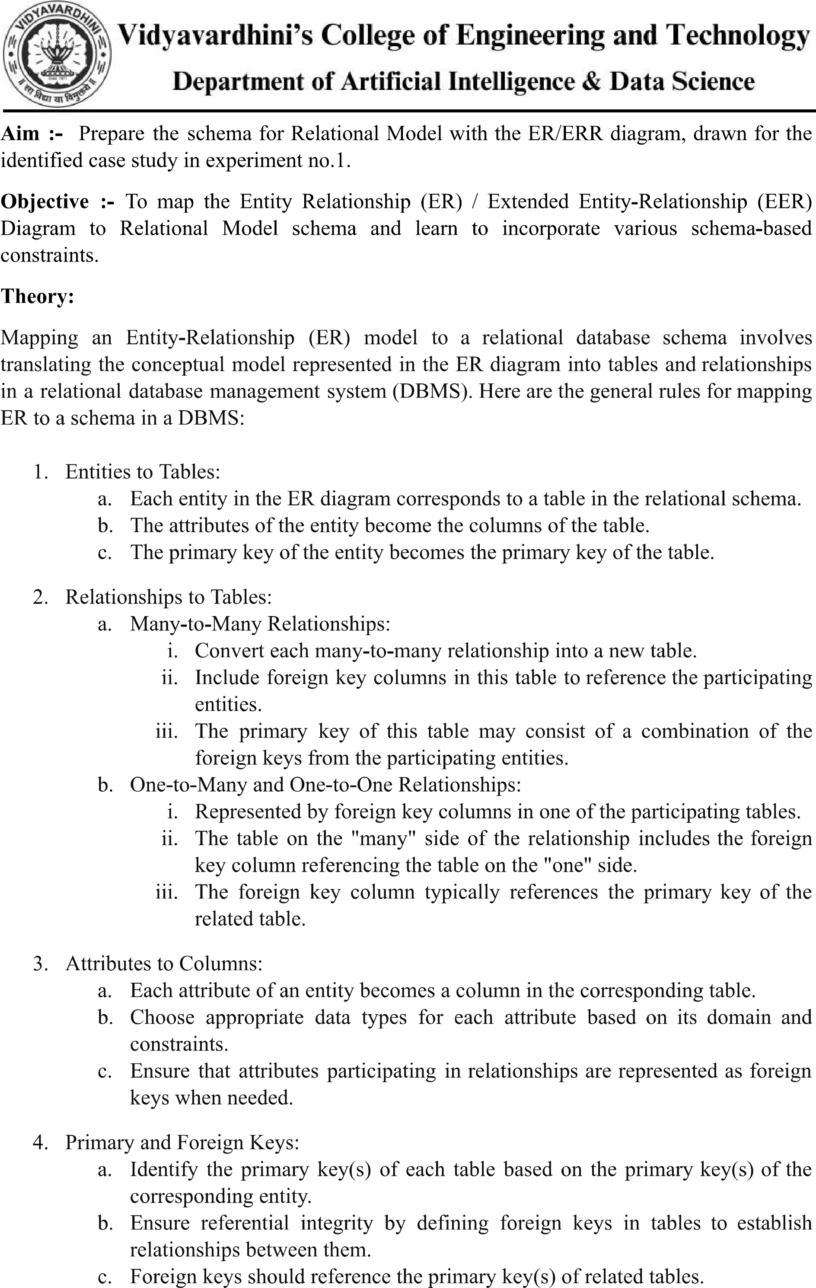



d. Ensure that foreign keys have appropriate constraints, such as ON DELETE CASCADE or ON UPDATE CASCADE, to maintain data integrity.

1. Cardinality Constraints:
   * 1. Use the cardinality constraints from the ER diagram to determine the multiplicity of relationships in the relational schema.
     2. Ensure that the constraints are enforced through the appropriate use of primary and foreign keys.
2. Normalization:
   * 1. Normalize the schema to minimize redundancy and dependency.
     2. Follow normalization rules such as First Normal Form (1NF), Second Normal Form (2NF), Third Normal Form (3NF), etc., to ensure data integrity and minimize anomalies.
3. Indexing and Optimization:
   * 1. Consider indexing frequently queried columns to improve query performance.
     2. Evaluate the schema design for optimization opportunities based on query patterns and performance requirements.

c. Ensure that foreign keys have appropriate constraints, such as ON DELETE CASCADE or ON UPDATE CASCADE, to maintain data integrity.

1. Cardinality Constraints:
   * 1. Use the cardinality constraints from the ER diagram to determine the multiplicity of relationships in the relational schema.
     2. Ensure that the constraints are enforced through the appropriate use of primary and foreign keys.
2. Normalization:
   * 1. Normalize the schema to minimize redundancy and dependency.
     2. Follow normalization rules such as First Normal Form (1NF), Second Normal Form (2NF), Third Normal Form (3NF), etc., to ensure data integrity and minimize anomalies.
3. Indexing and Optimization:
   * 1. Consider indexing frequently queried columns to improve query performance.
     2. Evaluate the schema design for optimization opportunities based on query patterns and performance requirements.

Implementation:

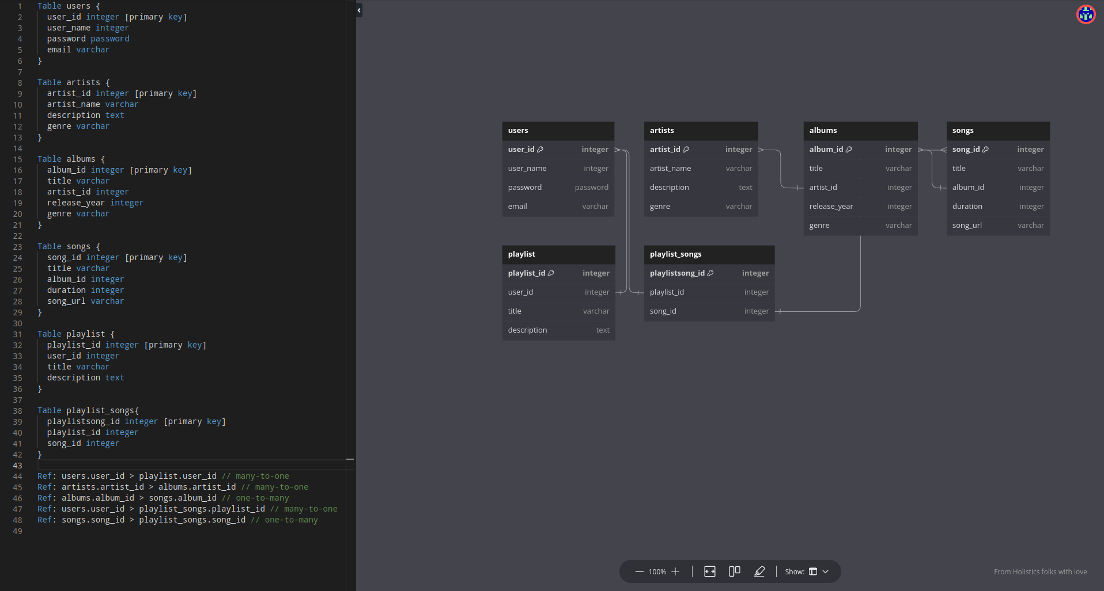



Conclusion:

* 1. write definition of relational schema and notations

Relational Schema and Notations:

Definition: Relational schema organizes data in a database. It consists of relation schemas, detailing attributes and types. Notations represent these schemas.

Notations:

Relation Name: Uppercase.

Attribute Names: Lowercase.

Attribute Types: Data types.

Primary Key: Underlined.

Foreign Key: Dashed underline or different font.

Referential Integrity Constraints: Arrows connecting foreign keys to primary keys.

* 1. write various schema-based constraints

Various Schema-based Constraints:

Primary Key Constraint: Ensures uniqueness.

Foreign Key Constraint: Maintains referential integrity.

Unique Constraint: Enforces uniqueness.

Check Constraint: Specifies conditions for validity.

Not Null Constraint: Requires non-null values.

Default Constraint: Provides default values.

Check Constraint: Limits acceptable values.

Assertion Constraint: Global condition for the database.



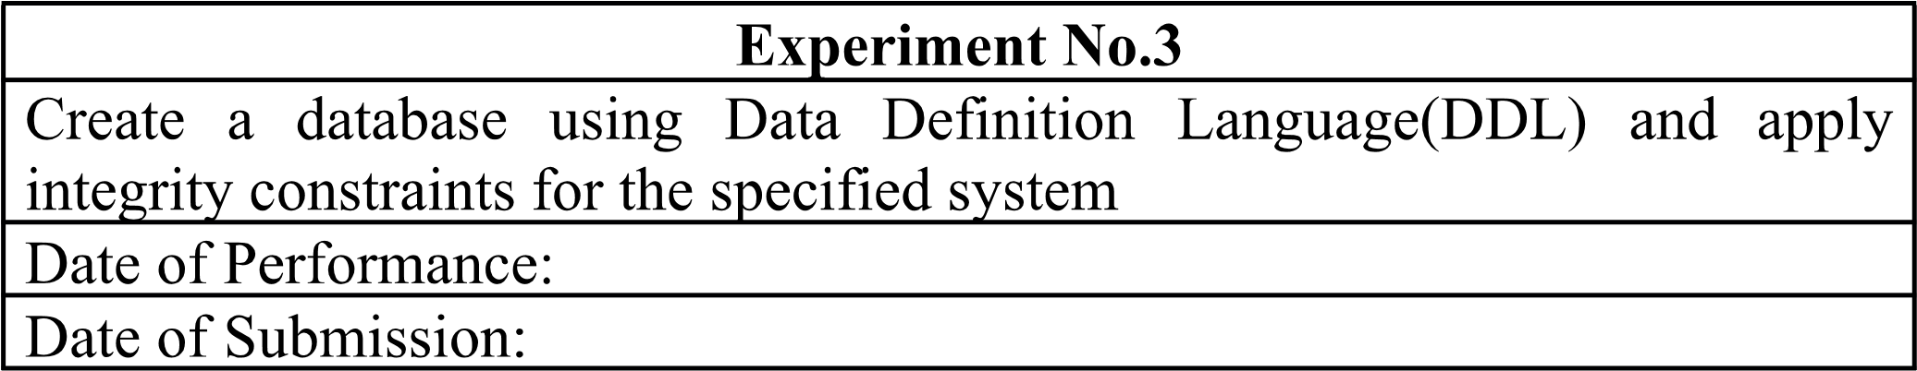



Aim:- Write a query to create tables for each relation in the relational schema of experiment no.2. Apply drop and alter commands on those tables.

Objective:- To learn commands of Data Definition Language(DDL) to create and define databases, and also learn to apply integrity constraints for the specified system.

Theory:

DDL Commands & Syntax:

Data Definition Language (DDL) is a subset of SQL and a part of DBMS(Database Management System). DDL consist of Commands to commands like CREATE, ALTER, TRUNCATE and DROP. These commands are used to create or modify the tables in SQL.

DDL Commands:

. Create

1. Alter
2. truncate
3. drop 5. Rename

CREATE:

This command is used to create a new table in SQL. The user must give information like table name, column names, and their data types.

Syntax-

CREATE TABLE table name(

column 1 datatype, column_2 datatype, column_ 3 datatype,

….

);

ALTER:

This command is used to add, delete or change columns in the existing table. The user needs to know the existing table name and can add, delete, or modify tasks easily.

Syntax-



ALTER TABLE table_name ADD column name datatype;

TRUNCATE :

This command is used to remove all rows from the table, but the structure of the table still exists.

Syntax

TRUNCATE TABLE table_name;

DROP :

This command is used to remove an existing table along with its structure from the Database.

Syntax-

DROP TABLE table name;

RENAME :

It is possible to change name of table with or without data in it using simple RENAME command. We can rename any table object at any point of time.

Syntax-

RENAME TABLE <Table_Name> To <New_Table_Name>;



Implementation:

Database:

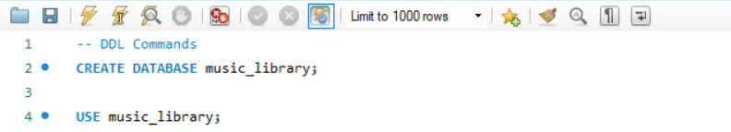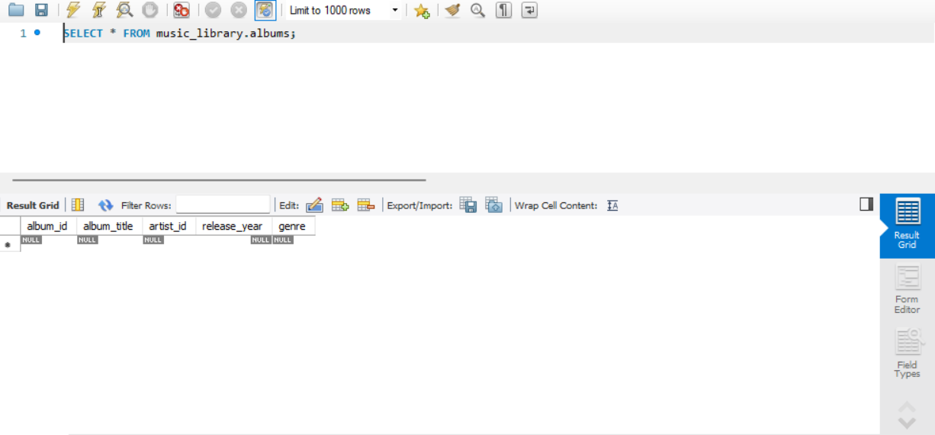

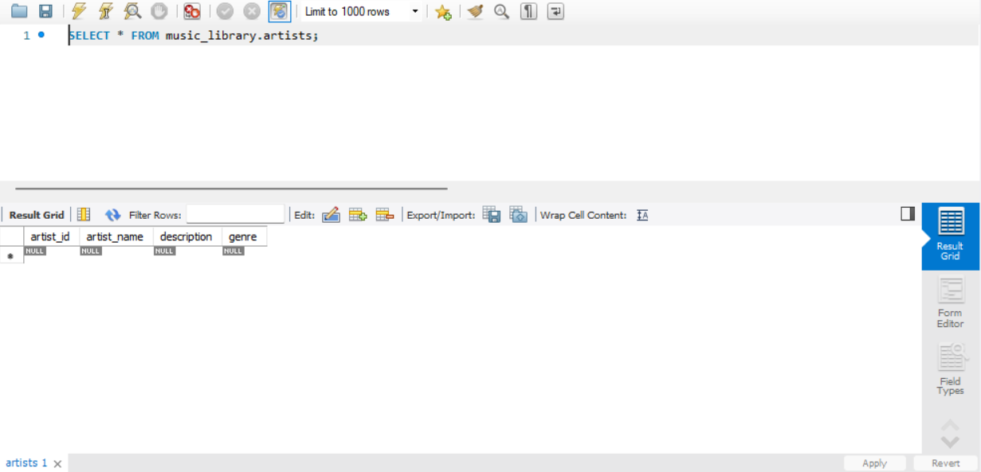

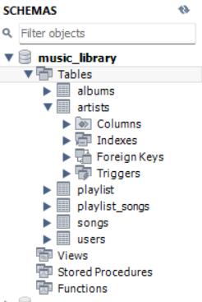

Conclusion:

1. Explain the concept of constraints in DDL. How are constraints used to enforce data integrity?

Constraints in DDL (Data Definition Language) are rules or conditions applied to the columns in a database table to enforce data integrity. They ensure that the data stored in the database meets certain criteria, preventing invalid or inconsistent data from being entered. Constraints can enforce various rules such as uniqueness, referential integrity, and data validity. For example, a primary key constraint ensures that each row in a table has a unique identifier, while a foreign key constraint ensures that values in a column match values in another table's column. By enforcing these constraints, data integrity is maintained, ensuring the accuracy, consistency, and reliability of the database.

1. What is the significance of data types in DDL? Provide examples of commonly used data types in DDL.

Data types in DDL specify the type of data that can be stored in a column of a database table. They define the format and range of values that can be assigned to a column, ensuring proper storage and manipulation of data. Commonly used data types in DDL include:

INTEGER: Used for storing whole numbers.

VARCHAR(n): Variable-length character string with a maximum length of 'n' characters.

DATE: Used for storing dates in the format 'YYYY-MM-DD'.

DECIMAL(p, s): Exact numeric data type with 'p' total digits and 's' digits to the right of the decimal point.



BOOLEAN: Used for storing true/false or 1/0 values.

TIMESTAMP: Used for storing date and time values in the format 'YYYY-MM-DD HH:MM:SS'.

CHAR(n): Fixed-length character string with a length of 'n' characters.

FLOAT: Approximate numeric data type used for storing floating-point numbers.

TEXT: Variable-length character string for storing large blocks of text. These data types allow database designers to define the structure of the database tables and ensure the appropriate handling of data.

 Aim :- Write insert query to insert rows for each table created of your database management system. Use update and delete commands to manipulate the inserted values in the table.

Objective :- To learn commands of Data Manipulation Language(DML) to insert, update or delete the values in the database system.

Theory:

Data Manipulation Language (DML) is a subset of SQL (Structured Query Language) used for managing data within relational database management systems (RDBMS). DML commands are used to perform operations such as inserting, updating, and deleting data from database tables.

1. Inserting Data

The INSERT statement is used to add new rows of data into a table. It specifies the table to insert data into and provides values or expressions for each column in the new row. If a column list is not specified, values must be provided for all columns in the table in the order they were defined.

Syntax:-

INSERT INTO table_name (column1, column2, column3) VALUES (value1, value2,

value3); 2. Updating Data

The UPDATE statement is used to modify existing data within a table. It allows you to change the values of one or more columns in one or more rows based on specified conditions. If no condition is specified, all rows in the table will be updated.

Syntax:

UPDATE table_name SET column1 = value1, column2 = value2 WHERE

condition; 3. Deleting Data

The DELETE statement is used to remove one or more rows from a table based on specified conditions. If no condition is specified, all rows in the table will be deleted.

Syntax:

DELETE FROM table_name WHERE condition; specified, all rows in the table will be deleted.

 Implementation:

INSERT:

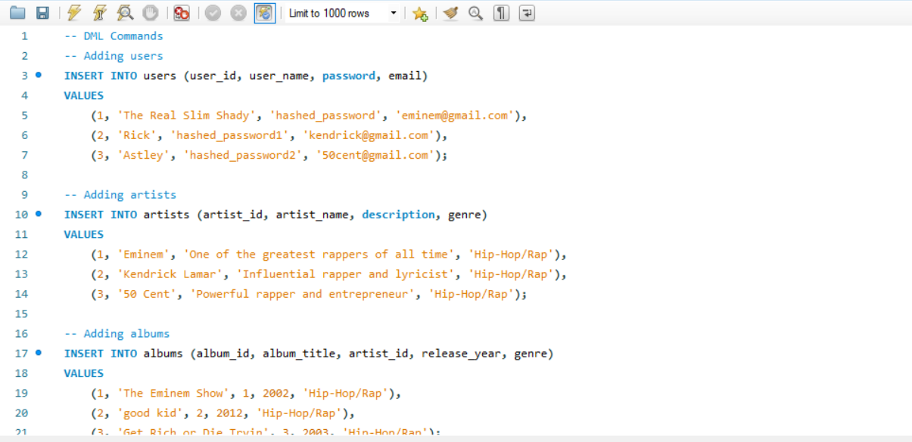

UPDATE:

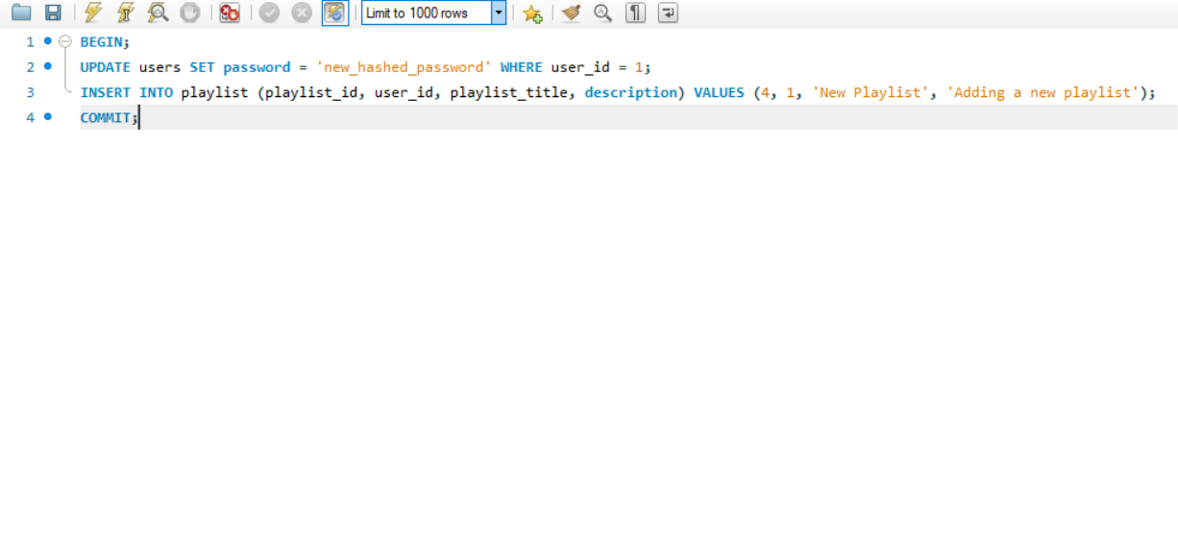

DELETE:

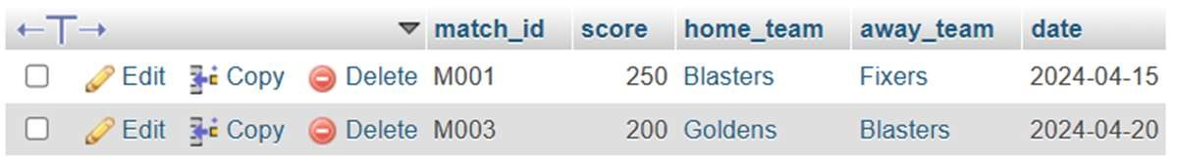

Conclusion:

* 1. Explain the role of database constraints in enforcing data integrity during DML operations.

Database constraints play a crucial role in enforcing data integrity during DML (Data Manipulation Language) operations by imposing rules and conditions on the data stored in the database tables. These constraints ensure that the data conforms to certain standards and requirements, preventing the insertion, modification, or deletion of data that could compromise its integrity. Constraints such as primary key, foreign key, unique, and check constraints help maintain consistency, accuracy, and reliability in the database by preventing invalid or inconsistent data from being introduced or manipulated.

* 1. How do you update multiple columns in a table using a single UPDATE statement?

To update multiple columns in a table using a single UPDATE statement, you specify the column names and their corresponding new values separated by commas within the SET clause of the UPDATE statement. For example:

UPDATE table_name

SET column1 = value1, column2 = value2, column3 = value3 WHERE condition;

This statement updates the values of column1, column2, and column3 in the specified table with the provided values, subject to the specified condition.

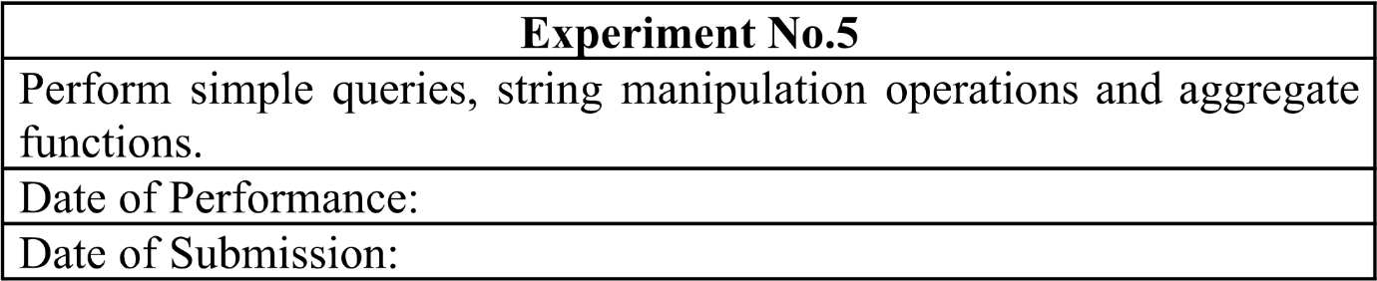

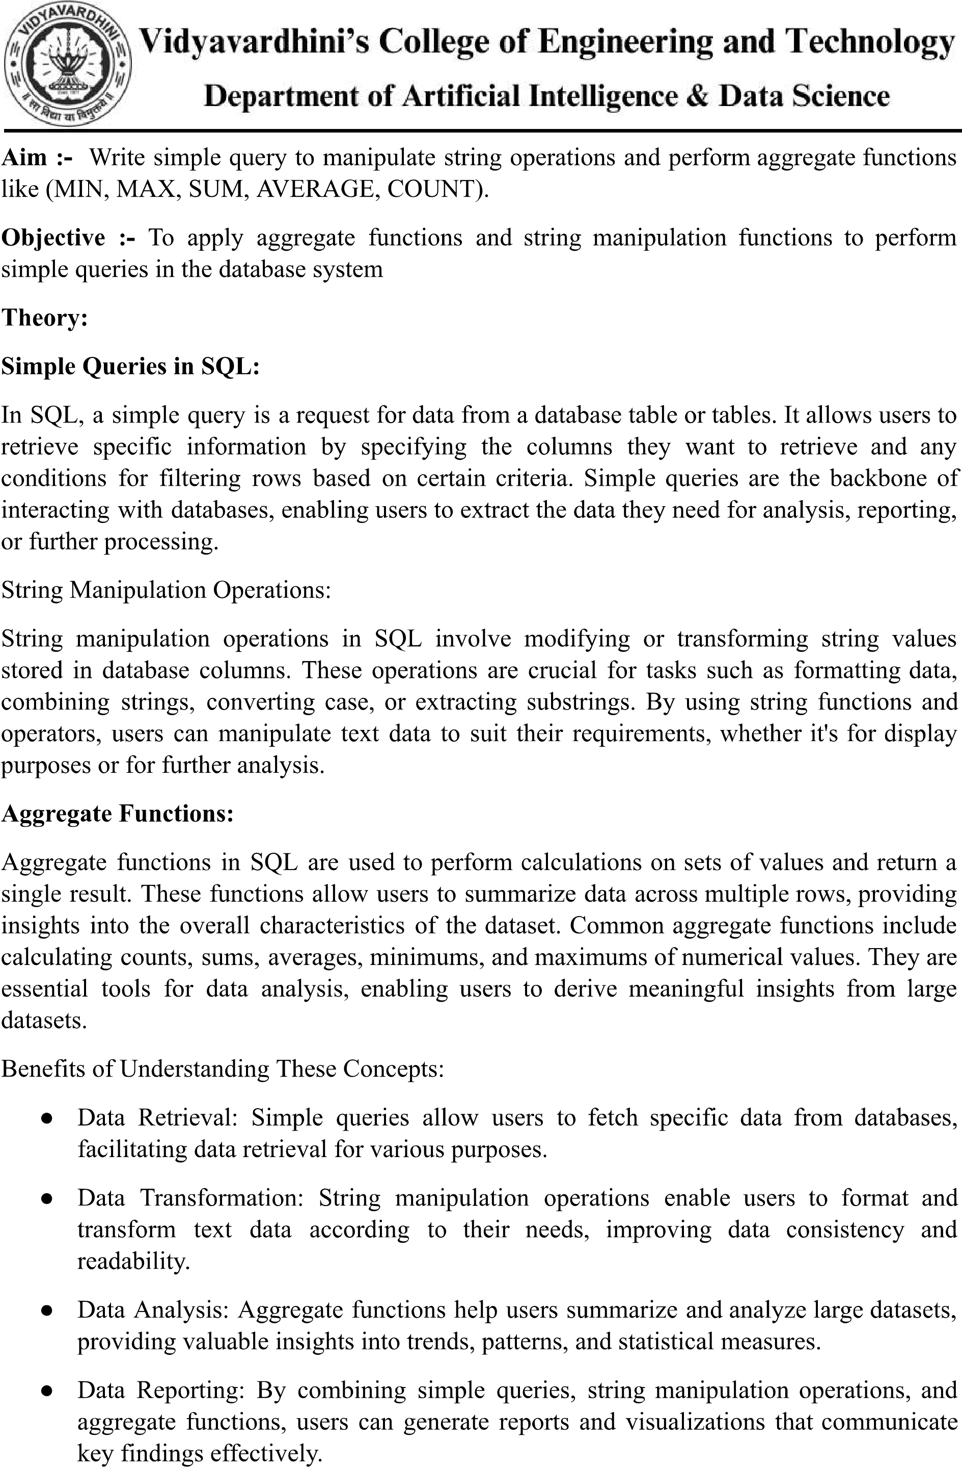



Implementation:

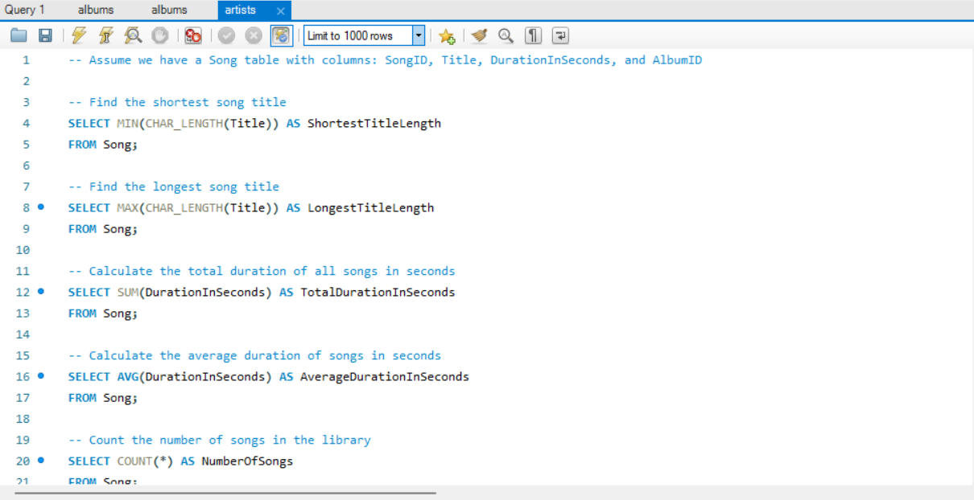

Conclusion:

1. Write syntax and explanation for each of the five aggregate functions

Aggregate functions are SQL functions used to perform calculations on sets of values and return a single result. Here's a brief explanation of each aggregate function along with the syntax and an example of its usage:

**MIN():**

* **Syntax:** **MIN(expression)**
* **Explanation:** Returns the minimum value of a set.
* **Example:** Find the shortest song title.

**MAX():**

* **Syntax:** **MAX(expression)**
* **Explanation:** Returns the maximum value of a set.
* **Example:** Find the longest song title.

**SUM():**

* **Syntax:** **SUM(expression)**
* **Explanation:** Calculates the sum of all values in a set.
* **Example:** Calculate the total duration of all songs in seconds.

**AVG():**

* **Syntax:** **AVG(expression)**
* **Explanation:** Calculates the average of all values in a set.
* **Example:** Calculate the average duration of songs in seconds.

**COUNT():**

* **Syntax:** **COUNT(*)** or **COUNT(expression)**
* **Explanation:** Counts the number of rows in a set. **COUNT(*)** counts all rows, while **COUNT(expression)** counts rows where the expression is not null.
* **Example:** Count the number of songs in the library.



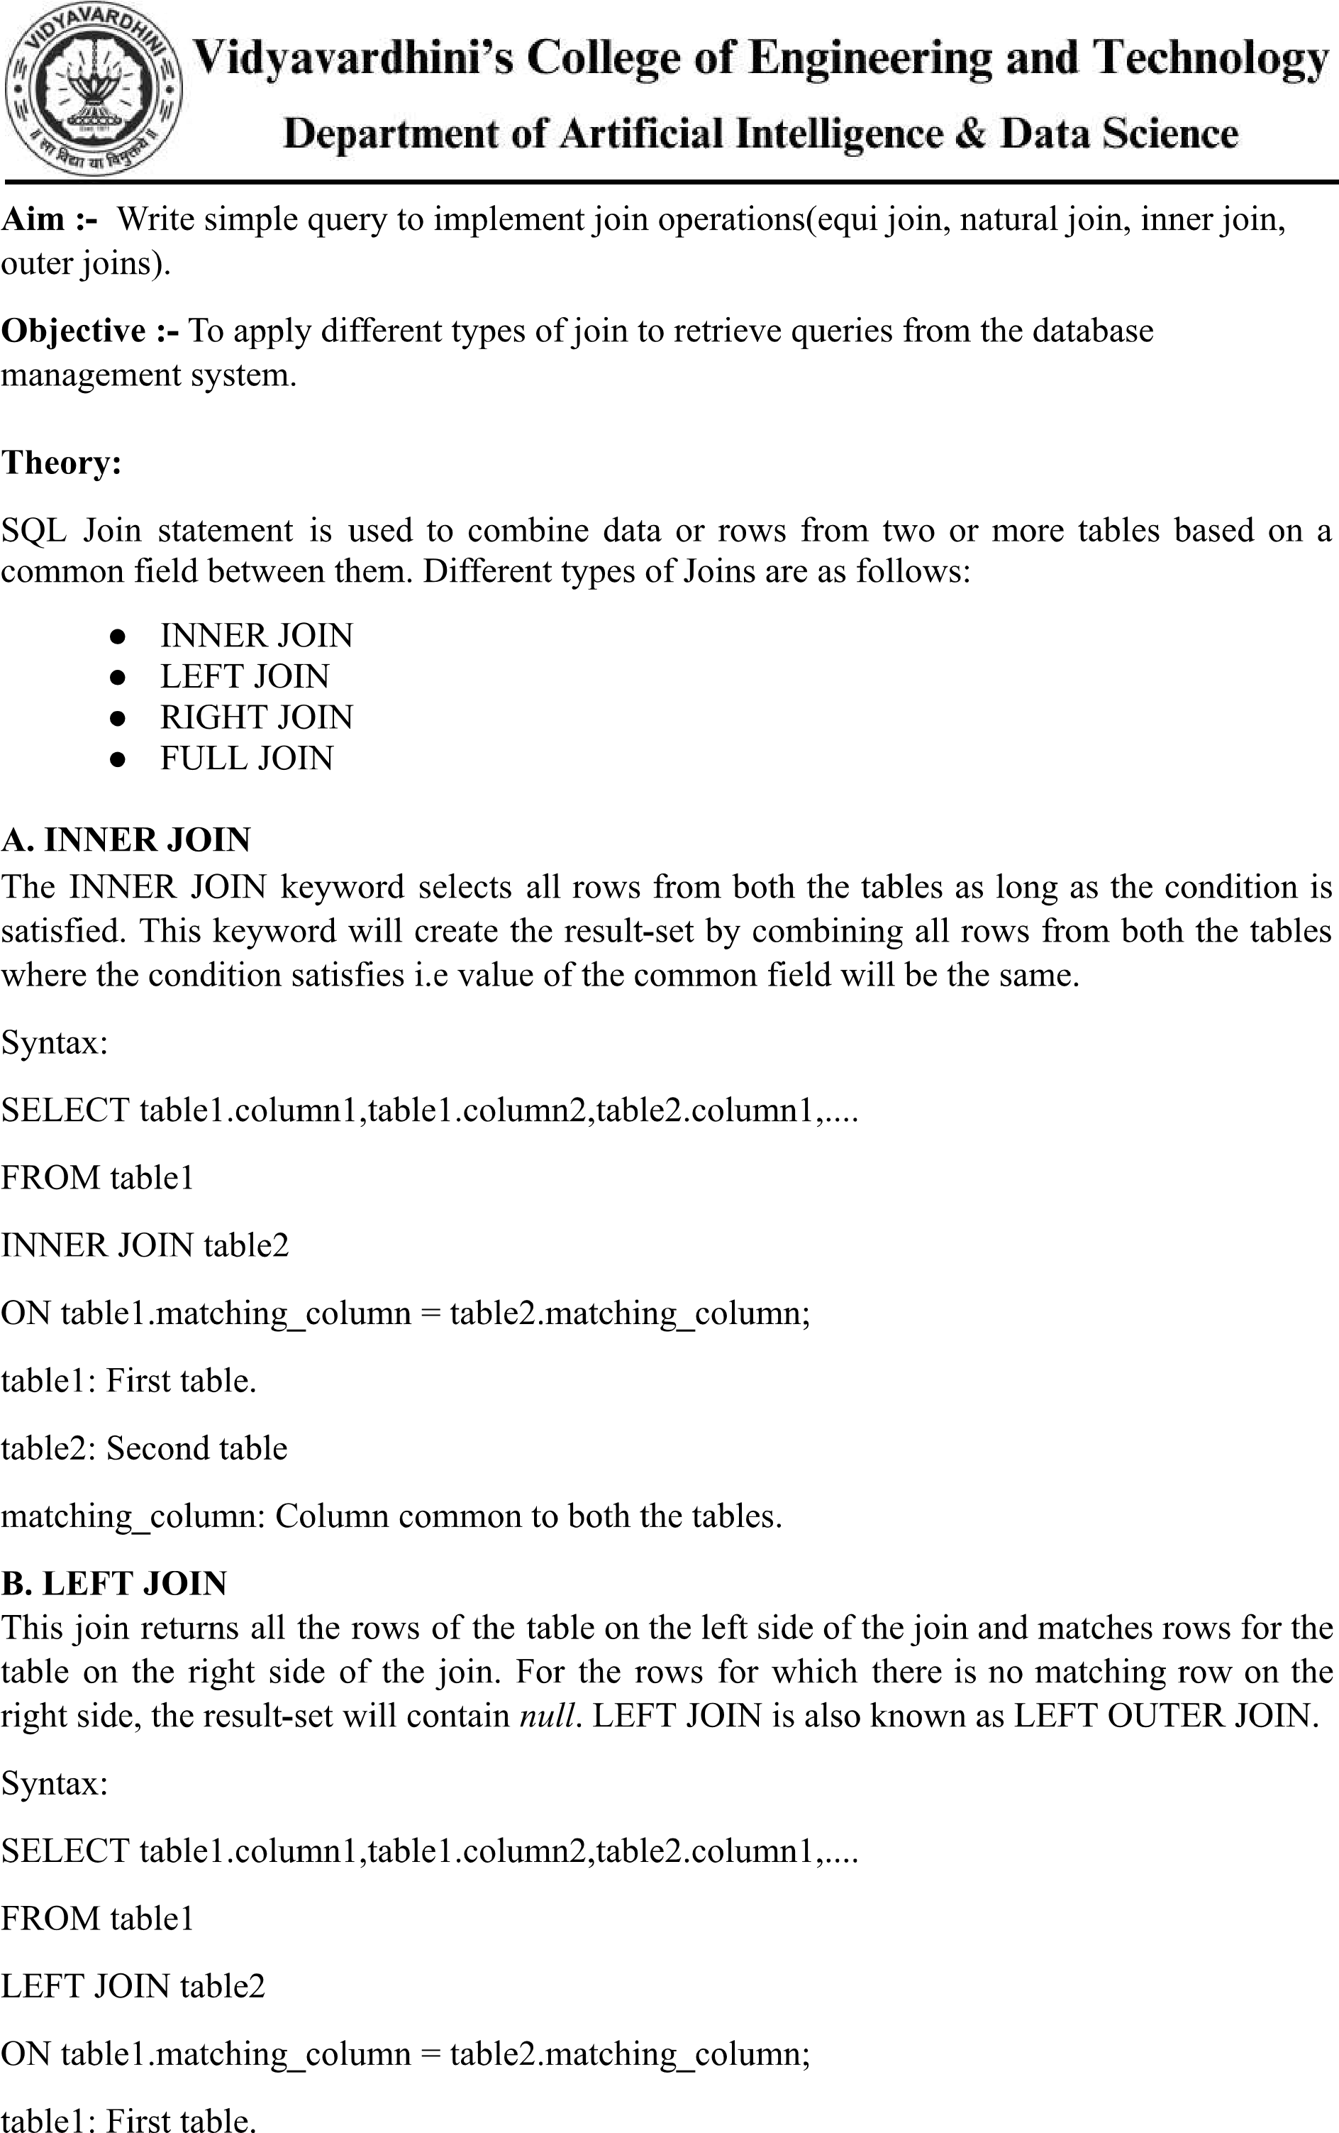

table2: Second table matching_column: Column common to both the tables.

C. RIGHT JOIN

RIGHT JOIN is similar to LEFT JOIN. This join returns all the rows of the table on the right side of the join and matching rows for the table on the left side of the join. For the rows for which there is no matching row on the left side, the result-set will contain null. RIGHT JOIN is also known as RIGHT OUTER JOIN.

Syntax:

SELECT table1.column1,table1.column2,table2.column1,....

FROM table1

RIGHT JOIN table2

ON table1.matching_column = table2.matching_column;

table1: First table. table2: Second table matching_column: Column common to both the tables.

D. FULL JOIN

FULL JOIN creates the result-set by combining results of both LEFT JOIN and RIGHT JOIN. The result-set will contain all the rows from both tables. For the rows for which there is no matching, the result-set will contain NULL values.

Syntax:

SELECT table1.column1,table1.column2,table2.column1,....

FROM table1

FULL JOIN table2

ON table1.matching_column = table2.matching_column;

table1: First table. table2: Second table matching_column: Column common to both the tables.

Implementation:

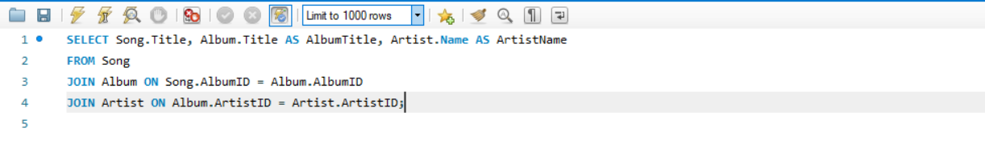**Equi Join:**

**Natural Join:**



**Inner Join:**

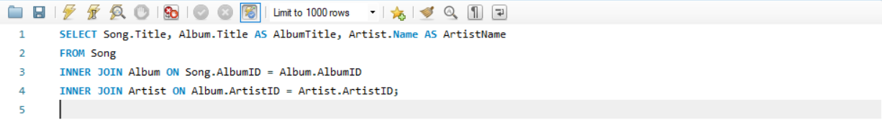**Left Outer Join:**

**Right Outer Join:**

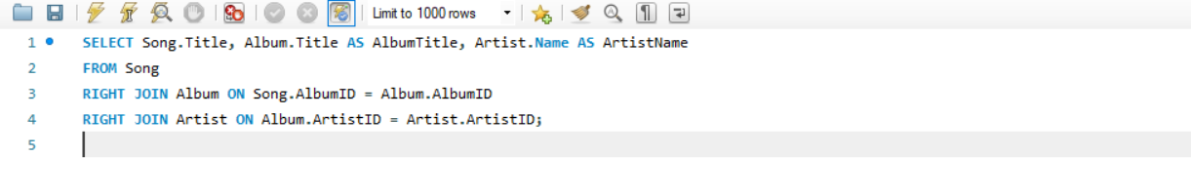

**Full Outer Join:** 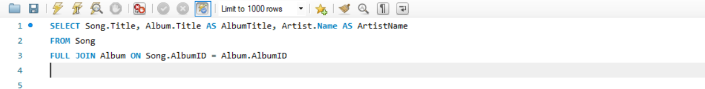

Conclusion:

1. Illustrate how to perform natural join for the joining attributes with different names with a suitable example.

Performing a natural join with joining attributes having different names requires explicitly specifying the join condition. Here's a concise example:

Example:

SELECT *

FROM Employees

NATURAL JOIN Departments

ON Employees.dept_id = Departments.department_id;

In this example, Employees and Departments tables have different column names (dept_id and department_id). The ON clause specifies the common columns for the natural join.

1. Illustrate significant differences between natural join, equi-join and inner join.

Differences Between Natural Join, Equi Join, and Inner Join:

Natural Join: Automatically matches columns with the same name but can produce unexpected results.

Equi Join: Specifies join conditions explicitly, allowing joining attributes with different names.

Inner Join: Returns rows that satisfy the join condition specified in the ON clause, providing control over the join condition.

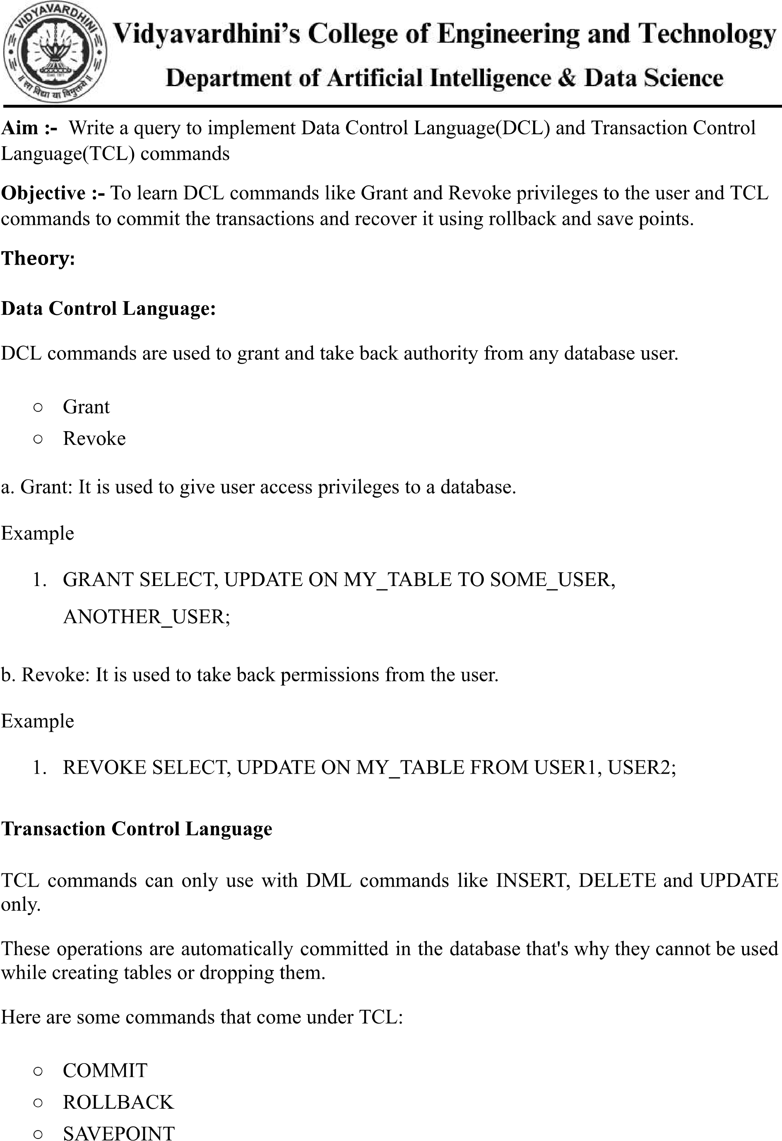



1. Commit: Commit command is used to save all the transactions to the database.

Syntax:

* 1. COMMIT;

Example:

* 1. DELETE FROM CUSTOMERS
  2. WHERE AGE = 25; 3. COMMIT;

1. Rollback: Rollback command is used to undo transactions that have not already been saved to the database.

Syntax:

* 1. ROLLBACK;

Example:

* 1. DELETE FROM CUSTOMERS
  2. WHERE AGE = 25; 3. ROLLBACK;

1. SAVEPOINT: It is used to roll the transaction back to a certain point without rolling back the entire transaction.

Syntax:

2. SAVEPOINT SAVEPOINT_NAME;



Implementation:

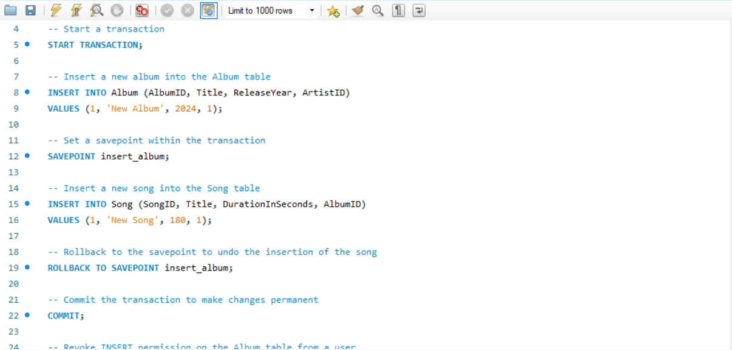

Conclusion:

* 1. Explain about issues faced during rollback in mysql and how it got resolved.

During rollback in MySQL, issues can arise if there are concurrent transactions or if the rollback process encounters errors such as deadlocks. These issues are resolved by ensuring proper transaction management, handling deadlock situations, and using appropriate isolation levels to minimize conflicts between transactions.

* 1. Explain how to create a user in sql.

To create a user in SQL, you typically use the CREATE USER statement followed by the username and password. Optionally, you can specify additional parameters such as permissions and privileges. For example:

CREATE USER 'username'@'hostname' IDENTIFIED BY 'password'.



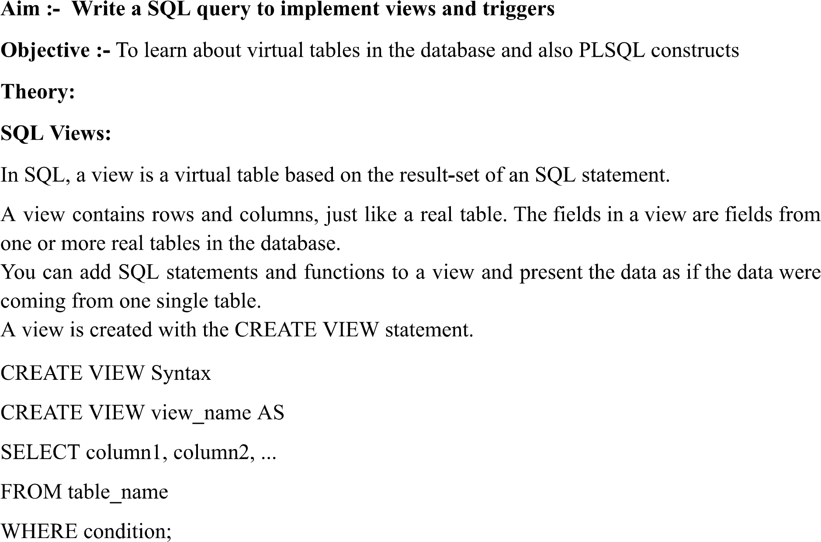

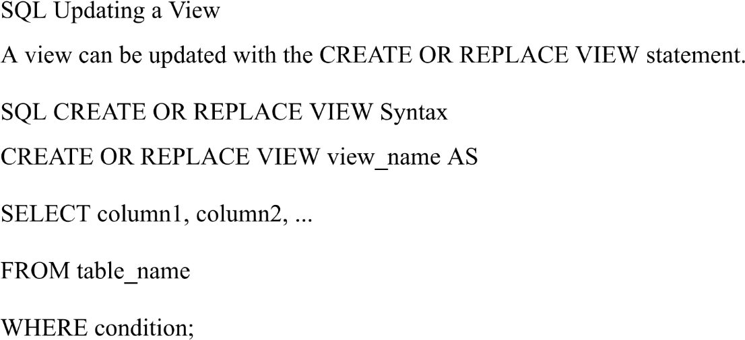

Trigger: A trigger is a stored procedure in the database which automatically invokes whenever a special event in the database occurs. For example, a trigger can be invoked when a row is inserted into a specified table or when certain table columns are being updated.

Syntax:

create trigger [trigger_name]

[before | after]

{insert | update | delete}

on [table_name]

[for each row]

[trigger_body]

Explanation of syntax:

1. create trigger [trigger_name]: Creates or replaces an existing trigger with the trigger_name.
2. [before | after]: This specifies when the trigger will be executed.
3. {insert | update | delete}: This specifies the DML operation.
4. on [table_name]: This specifies the name of the table associated with the trigger. 5. [for each row]: This specifies a row-level trigger, i.e., the trigger will be executed for each row being affected.
5. [trigger_body]: This provides the operation to be performed as trigger is fired .

IMPLEMENTATION:

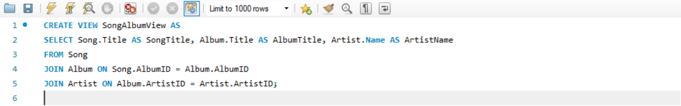

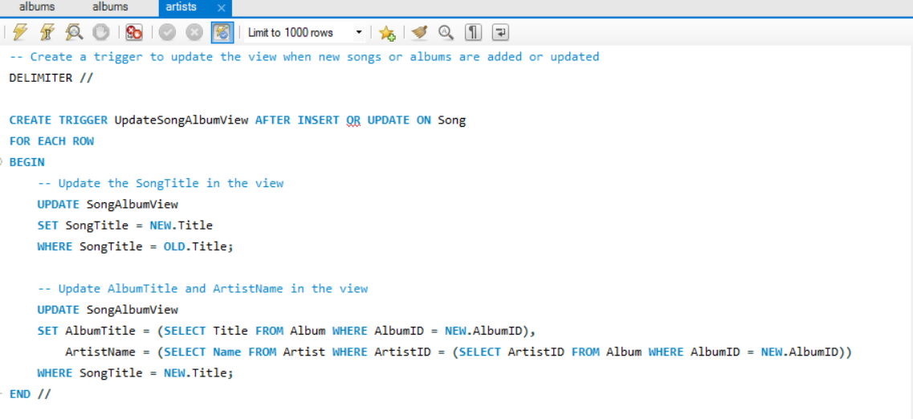

Result:

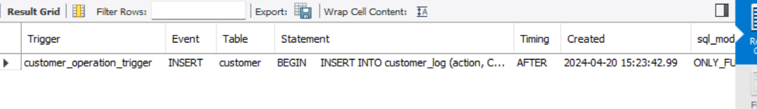

Conclusion:

1. Brief about the benefits for using views and triggers.

Views simplify queries, enhance security, abstract table structures, and optimize performance. Triggers enforce data integrity, audit changes, enforce business logic, and support replication.

1. Explain different strategies to update views

Updating views can be done directly, by updating base tables, using triggers, or by recreating views. These methods offer varying degrees of control and are applied based on the view's complexity and update requirements.

Aim :- Write a java program to connect Java application with the MySQL database

Objective :- To learn database connectivity

Theory:

Database used : MySql

1. Driver class: The driver class for the mysql database is com.mysql.jdbc.Driver. 2. Connection URL: The connection URL for the mysql database is jdbc:mysql://localhost:3306/loan management where jdbc is the API, mysql is the database, localhost is the server name on which mysql is running, can also use IP address, 3306 is the port number and loan management is the database name. 3. Username: The default username for the mysql database is Hiren.

4. Password: It is the password given by the user at the time of installing the mysql database. Password used is “ “.

To connect a Java application with the MySQL database, follow the following steps.

* First create a database and then create a table in the mysql database. ● To connect java application with the mysql database, mysqlconnector.jar file is required to be loaded.
* download the jar file mysql-connector.jar
* add the jar file to the same folder as the java program.
* Compile and run the java program to retrieve data from the database.

Conclusion: Data has been retrieved successfully from a table by establishing database connectivity of java program with mysql database.

2. Explain steps to connect a java application with the MySQL database

* Download and install MySQL Connector/J.
* Include the MySQL Connector/J JAR file in your Java project.
* Import the necessary classes from the `java.sql` package.
* Use the `DriverManager.getConnection()` method to establish a connection to the MySQL database.
* Provide the JDBC URL, username, and password for authentication.
* Perform database operations using `Statement` or `PreparedStatement` objects.
* Close the connection and resources after completing the database operations.

Implementation:

import java.sql.*;

public class MusicLibraryManager {

// JDBC URL, username, and password of MySQL server

private static final String JDBC_URL = "jdbc:mysql://localhost:3306/music_library";

private static final String USERNAME = "your_username";

private static final String PASSWORD = "your_password";

public static void main(String[] args) {

try (Connection connection = DriverManager.getConnection(JDBC_URL, USERNAME, PASSWORD)) {

System.out.println("Connected to the database.");

// Example SQL query to retrieve data

String sql = "SELECT * FROM Song";

try (Statement statement = connection.createStatement();

ResultSet resultSet = statement.executeQuery(sql)) {

// Process the result set

while (resultSet.next()) {

int songId = resultSet.getInt("SongID");

String title = resultSet.getString("Title");

int duration = resultSet.getInt("DurationInSeconds");

System.out.println("Song ID: " + songId + ", Title: " + title + ", Duration: " + duration + " seconds");

}

}

} catch (SQLException e) {

System.err.println("Error connecting to the database: " + e.getMessage());

}

}

}

Conclusion: Data has been retrieved successfully from a table by establishing database connectivity of java program with mysql database.

2. Explain steps to connect a java application with the MySQL database

* Download and install MySQL Connector/J.
* Include the MySQL Connector/J JAR file in your Java project.
* Import the necessary classes from the `java.sql` package.
* Use the `DriverManager.getConnection()` method to establish a connection to the MySQL database.
* Provide the JDBC URL, username, and password for authentication.
* Perform database operations using `Statement` or `PreparedStatement` objects.
* Close the connection and resources after completing the database operations.

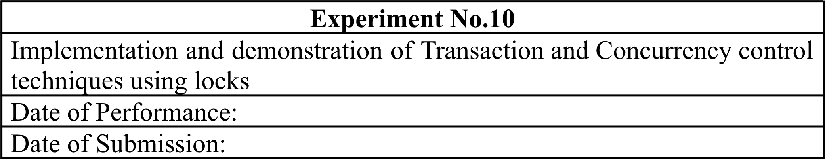

Aim :- Write a query to lock and unlock a table for transaction and concurrency control. Objective :- To learn locking of tables for transaction processing and concurrency control. Theory:

A lock is a mechanism associated with a table used to restrict the unauthorized access of the data in a table. MySQL allows a client session to acquire a table lock explicitly to cooperate with other sessions to access the table's data. MySQL also allows table locking to prevent unauthorized modification into the same table during a specific period.

Table Locking in MySQL is mainly used to solve concurrency problems. It will be used while running a transaction, i.e., first read a value from a table (database) and then write it into the table (database).

MySQL provides two types of locks onto the table, which are:

READ LOCK: This lock allows a user to only read the data from a table. WRITE LOCK: This lock allows a user to do both reading and writing into a table. The following is the syntax that allows us to acquire a table lock explicitly: LOCK

TABLES table_name [READ | WRITE];

The following is the syntax that allows us to release a lock for a table in MySQL:

UNLOCK TABLES;

Conclusion: Locking and unlocking of tables is achieved and verified using insert command in the same table of a database system.

1. Explain Transaction and Concurrency control techniques using locks.

Transactions ensure that a series of database operations are executed as a single unit of work, either all succeed or none do. Concurrency control techniques using locks manage access to shared resources in a multi-user environment. Locks can be applied at various levels, such as database, table, or row, to prevent conflicts between transactions.

In short, transactions ensure atomicity, consistency, isolation, and durability of database operations, while concurrency control techniques using locks prevent data inconsistency and ensure data integrity by managing concurrent access to shared resources.

Implementation:

-- Lock the Song table for write operations

LOCK TABLES Song WRITE;

-- Start a transaction

START TRANSACTION;

-- Perform operations on the locked table (e.g., insert, update, delete)

-- Commit the transaction

COMMIT;

-- Unlock the table after transaction completion

UNLOCK TABLES;

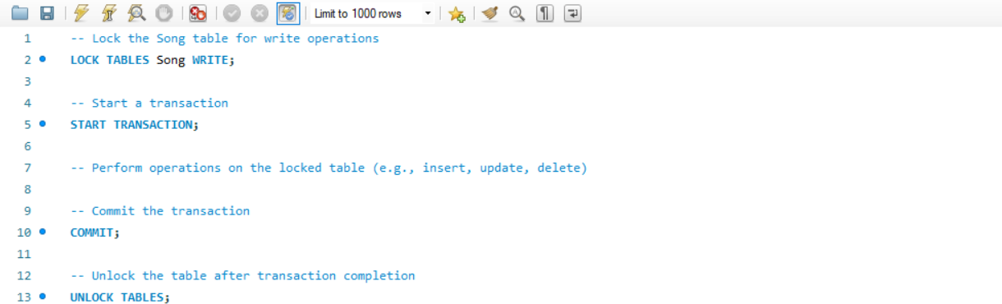

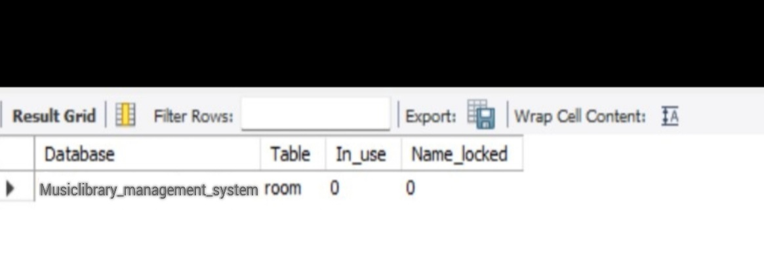

Conclusion: Locking and unlocking of tables is achieved and verified using insert command in the same table of a database system.

1. Explain Transaction and Concurrency control techniques using locks.

Transactions ensure that a series of database operations are executed as a single unit of work, either all succeed or none do. Concurrency control techniques using locks manage access to shared resources in a multi-user environment. Locks can be applied at various levels, such as database, table, or row, to prevent conflicts between transactions.

In short, transactions ensure atomicity, consistency, isolation, and durability of database operations, while concurrency control techniques using locks prevent data inconsistency and ensure data integrity by managing concurrent access to shared resources.